**Baston105 Class Project**

**Mehmet Seven**

**210704303**

**Problem Definition:**

This application is designed for use in nursing homes. Patients staying in nursing homes usually stay for a long time (average 2-3 years). Therefore, it is important to note everything about the patients in terms of the treatment to be done about them. In nursing homes, the doctor (usually a neurologist) who checks the patients weekly, arranges the most appropriate treatment for the patients and observes the results of these treatments together with the nurses. Nurses in nursing homes keep records of all positive or negative events they observe in patients. With all the information recorded as a result of these observations, the doctor arranges the treatment of the patients and requests extra treatment if necessary. A lot of documents are required for all these transactions and all the recorded information.

Purposes of this application:

* Nurses keep all documents containing patient information in a single mobile device.
* Carrying a single mobile device instead of carrying dozens of files during doctor's visits (for the doctor to look at the patient's information and see positive or negative events. For the patient to have a look at her/him current treatment and chronic diseases).
* Easy editing of patient information.
* The mobile device takes up much less space than dozens of patient files.
* Patient files can be torn, worn or lost. Thanks to the backup on the mobile device, the recorded information is stored much more securely than the patient file.
* In addition to this convenience, it creates a more environmentally friendly system by reducing paper waste (One of the biggest problems of humanity these days is that non-environmentally friendly consumers harm nature and the areas we live in become less quality).

**System Requirements:**

**Client(Doctor/Nurse)**

* User login and registration page. User can login on this page. If you don't have a membership, you can sign up.
* User(Doctor/Nurse) can create/delete profile for patient.
* Profile Content:

-Past illnesses of the patient and current illnesses of the patient.

-The content of the patient's routine treatment (the drugs he is currently using).

-The patient's medication hours.

-Extra treatments to be applied to the patient (temporary treatment given upon the doctor's request).

-User can Edit patient's information.

-Calendar pages with treatment changes and important events will be created. Thanks to these calendar pages, doctors and nurses will be able to review all treatment changes and important events in the past.

**Server:**

-Database for each patient.

-Database for each Events.

-Database for each Treatments.

**System Architecture:**

**Class Diagram:**

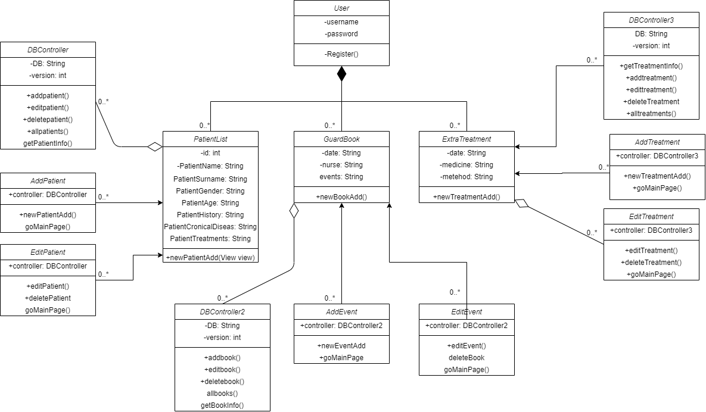

**Use Case Diagram:**

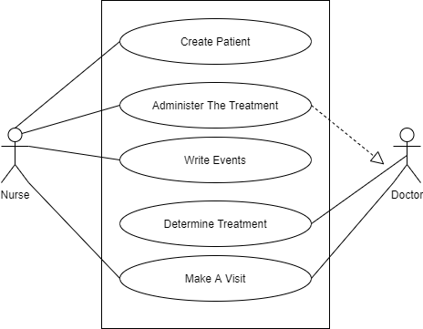

**Activity Diagram:**

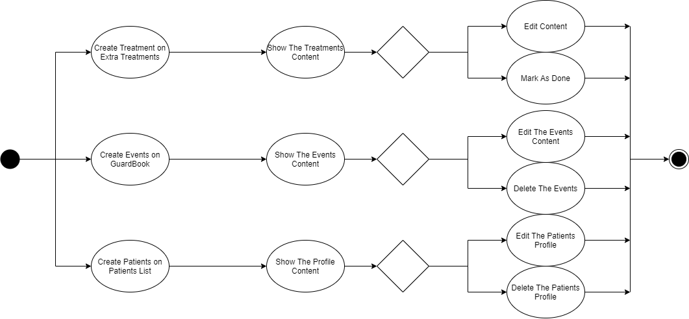

**Pages:**

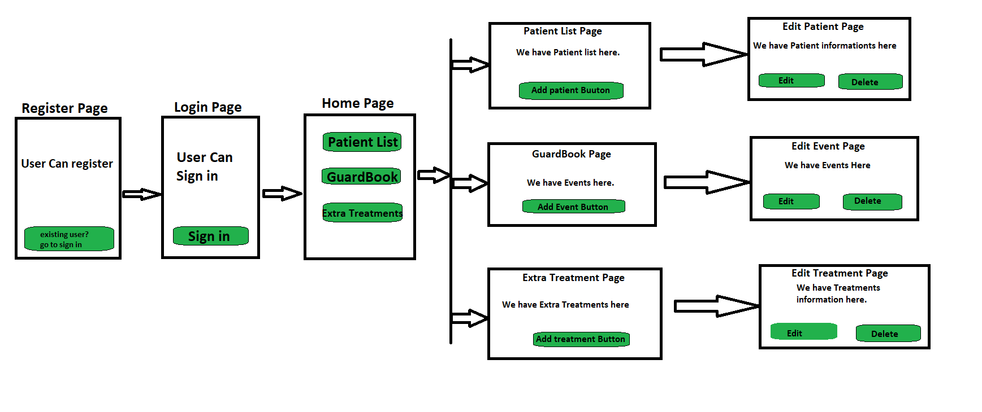

**Database Tables:**

**User Database Table:**

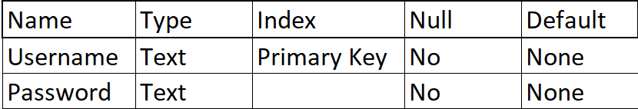

**Treatment Database Table:**

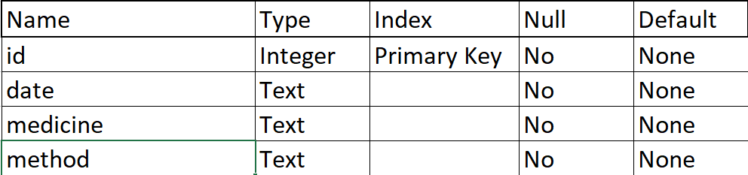

**GuardBook Database Table:**

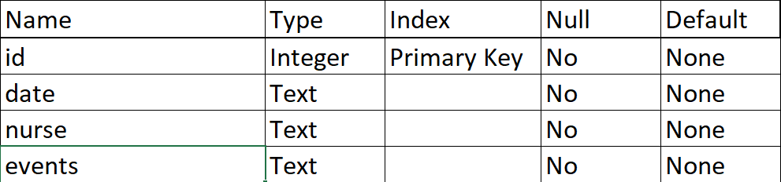

**PatientList Database Table:**

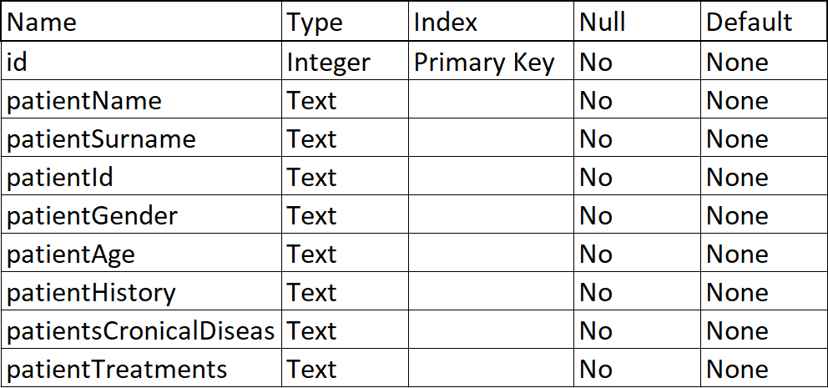

**Output Screens:**

**Register Screen Output:**

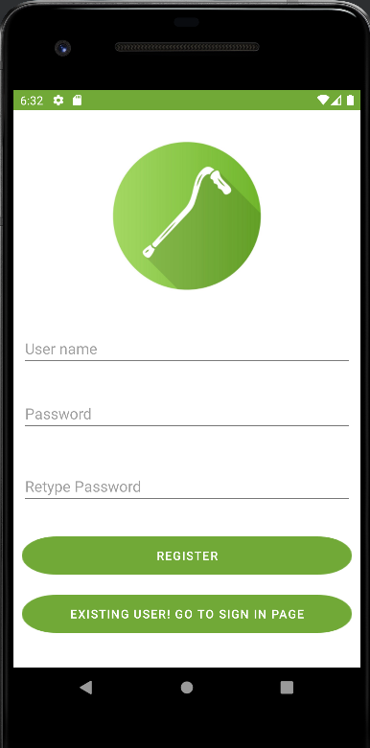

**Login Screen Output:**

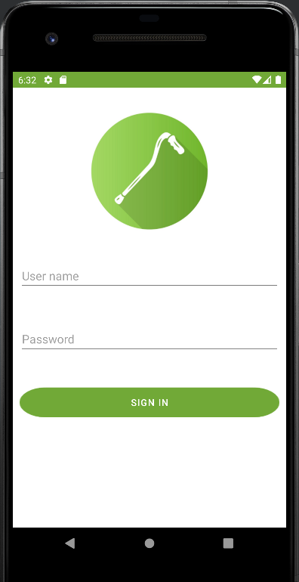

**Home Page Output:**

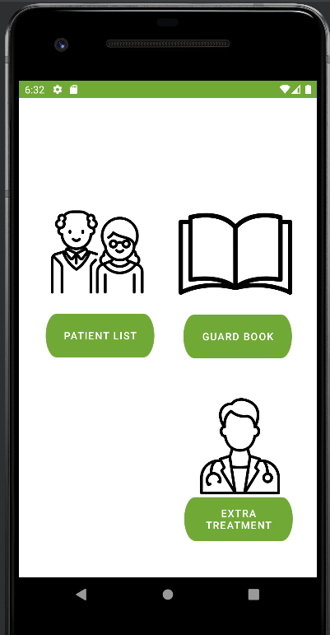

**Patient list Outputs(Scrollview Page):**

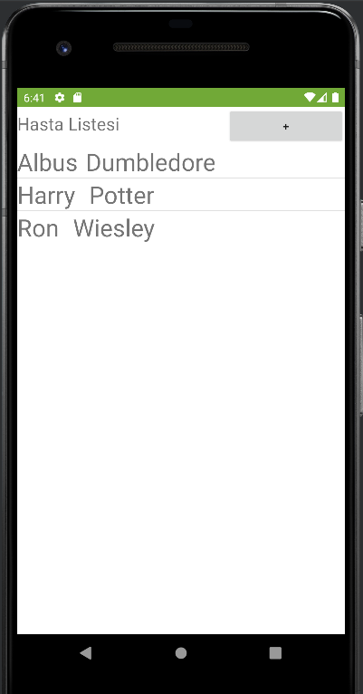

**Add Patient Page Output(Scrolview Page):**

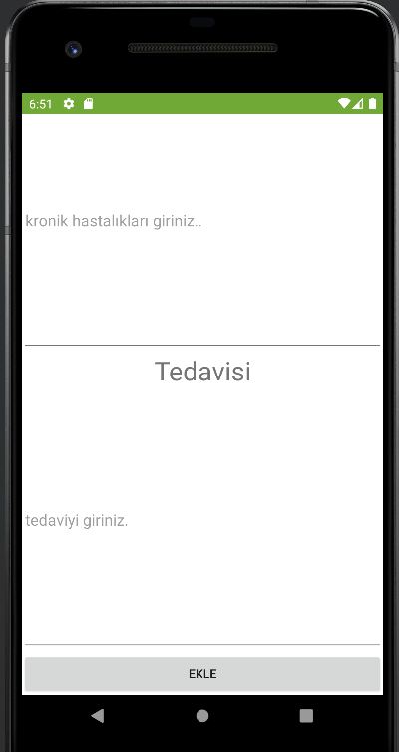

**Edit or Delete Patient Page(ScrollView Page):**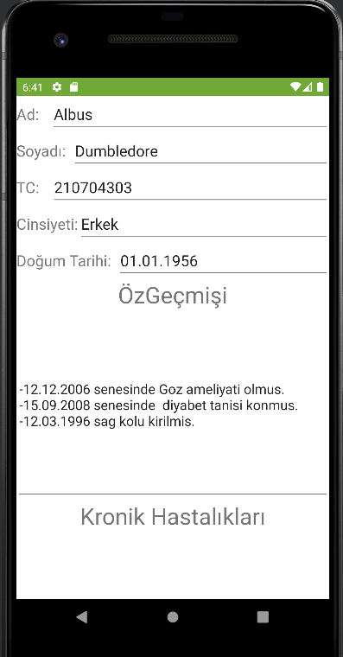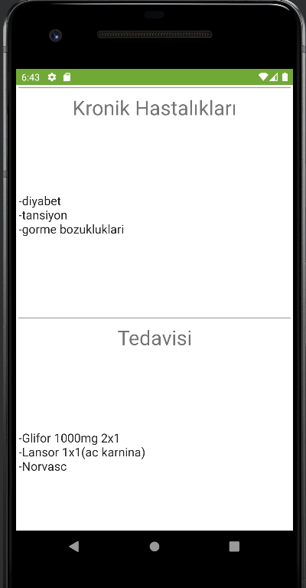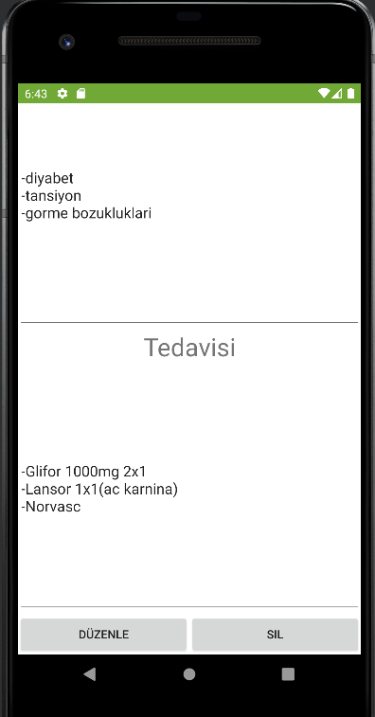

**GuardBook List Page(ScrollView Page):**

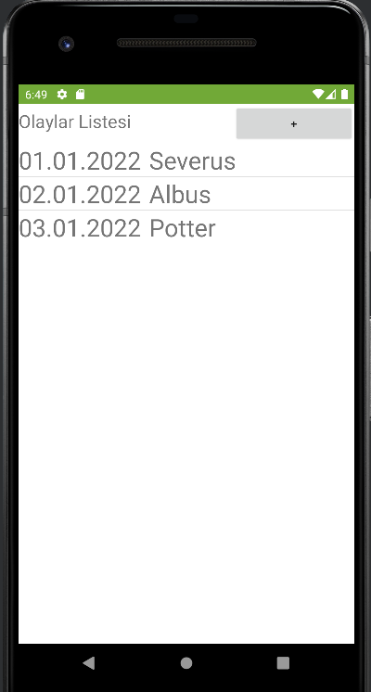

**Add Event to GuardBook Page(ScrollView Page):**

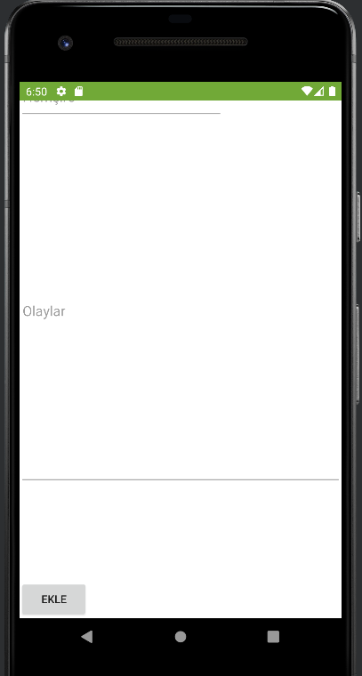

**Edit Or Delete Events of GuardBook Pages(ScrollView):**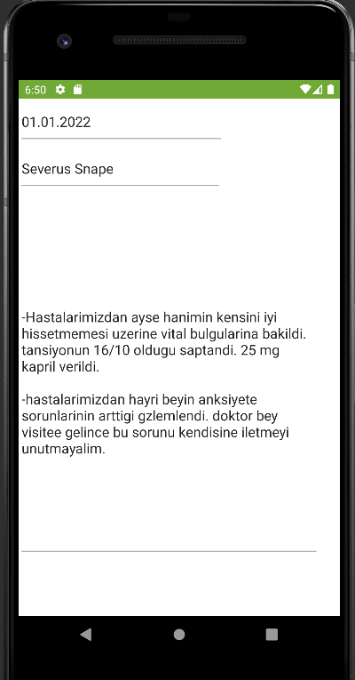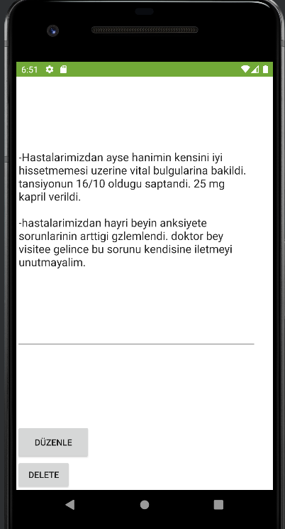

**Extra Treatments List Page(ScrollView Page):**

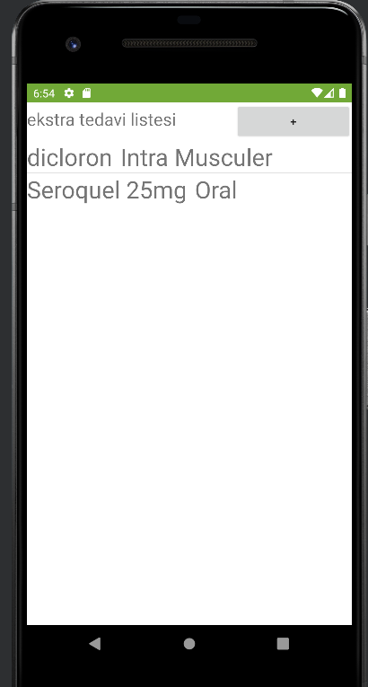

**Add Treatment Page(ScrollView):**

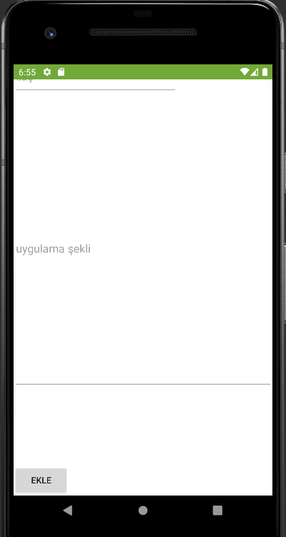

**Edit or Mark as Done Pages(ScrollView):**

